**// Subroutine : UpdateButtonClick_CUSOMTIZE_POCKET()**

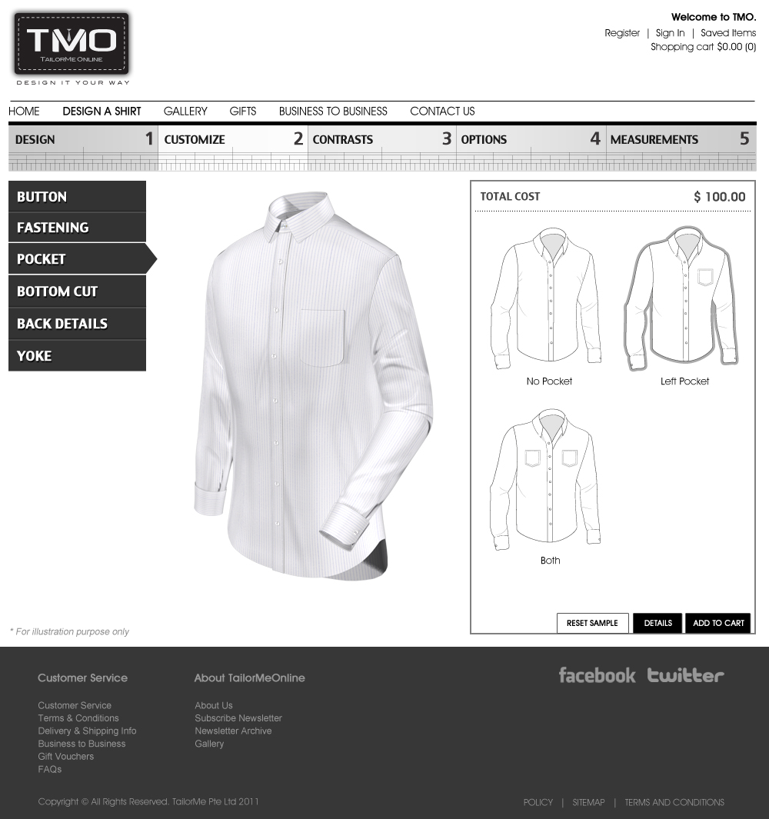

Upon clicking “No Pocket”:

ShirtLyr04[5] = “Hide”;

Call Subroutine : RefreshFilenames();

Call Subroutine : DisplayFullview(); // This updates the full shirt window

Upon clicking “Left Pocket”:

ShirtLyr04[5] = “Show”;

ShirtLyr04[2] = “LeftPocket.”;

Call Subroutine : RefreshFilenames();

Call Subroutine : DisplayFullview(); // This updates the full shirt window

Upon clicking “Both”:

ShirtLyr04[5] = “Show”;

ShirtLyr04[2] = “BothPocket.”;

Call Subroutine : RefreshFilenames();

Call Subroutine : DisplayFullview(); // This updates the full shirt window

**// End of Subroutine : UpdateButtonClick_CUSOMTIZE_POCKET()**